Created by Jake and Vinay

******

***UID key creation process***

**Version 1.0**

|  |
| --- |
|  |

## Connect cable to UID writer, key and laptop

|  |  |
| --- | --- |
| C:\Users\dwiegel\AppData\Local\Microsoft\Windows\INetCache\Content.Word\20200923_144635.jpg  Place the single USB end of the programming cable into your laptop, “Y” end USB into the programmer and the key you want to program into the “ID Key” port. Terminal application |  |

Your laptop should already have the Microsoft terminal application. If not, please download from Microsoft site.

Bring up the application. It should default to the COM port of what the cable is using. Baud rate will be 115200. All the other fields should be good at default.

Click “Connect”.

## Verify key read

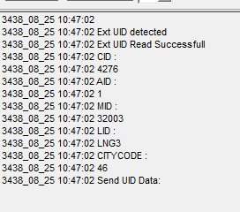

Flip the UID programmer switch to “On”. It’ll initially read what the key is programmed for.

## Write new key info



In the send box, put the following info. Note – Yellow fields will be change from key to key

4254,1,32053,CF21,47;

Fields:

4254 – your city’s customer code

1 – default area code for a meter

32053 – the meter ID you want to program. This will vary from key to key

CF21 – the meter name you want. Will also vary

47 – Colorado Springs’ city code

NOTE – the meter ID and meter name have to match exactly with what’s built in PEMS otherwise the meter won’t register to the network. For instance, if meter is built as CF 21 (with space) as opposed to CF21 (without), you need to type it the same.

For this meter however in PEMS, we’re good:

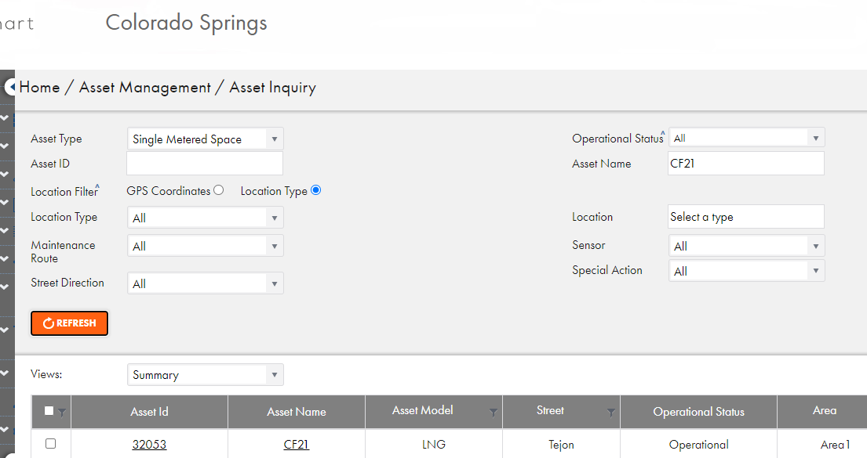

Hit “Send” in terminal. New key info will be written.

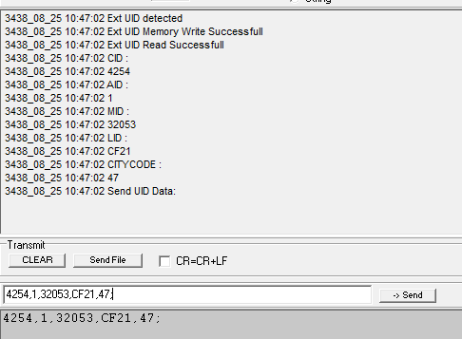

## Re-read key to verify

Switch programmer off and then on again to verify successful write:

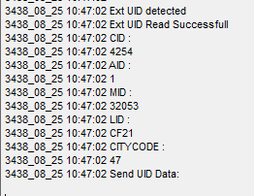

## When Done

Turn off the programmer. Inside is a standard LNG battery. If switched off after use, you’ll very rarely ever have to change it.